Flights & Passengers

*Subject: Flight booking*

*School: ПГКПИ Бургас*

*Martin Sevov* [*mssevov18@codingburgas.bg*](mailto:mssevov18@codingburgas.bg)

*Boris Kanev* [*BBKanev18@codingburgas.bg*](mailto:BBKanev18@codingburgas.bg)

*Hristo Hristov* [*hshristov18@codingburgas.bg*](mailto:hshristov18@codingburgas.bg)

*Teacher: Petar Georgiev*

What is Flights & Passengers?

Flight & Passengers is a program that makes flight booking easier than ever before. It solves the problem of complex and long old way to book flights and edit the flight or client information. It will be mainly used by flight companies.

How does it work?

Flights and Passengers is a C++ program with over 780 lines of code. It includes 3 libraries and multiple functions with different objectives.

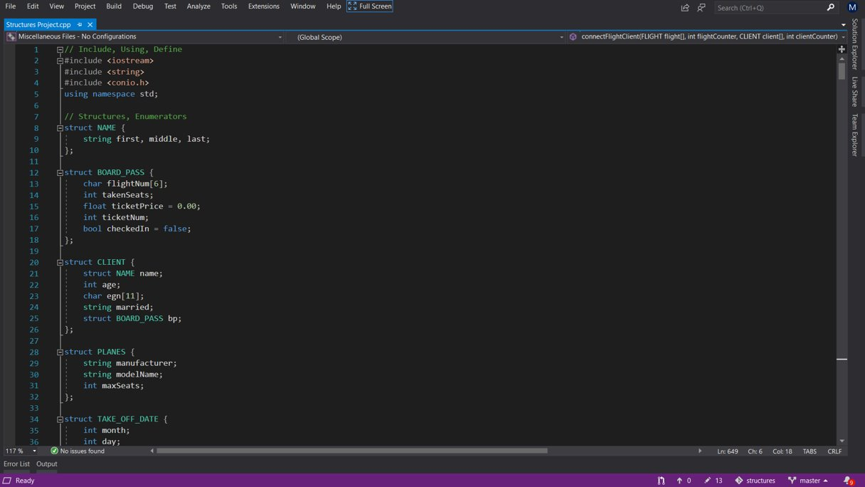

Some of the functions included in Flights and Passengers: registering, editing & removing flights or clients including day, month, flight num and more check functions to ensure the information is valid.

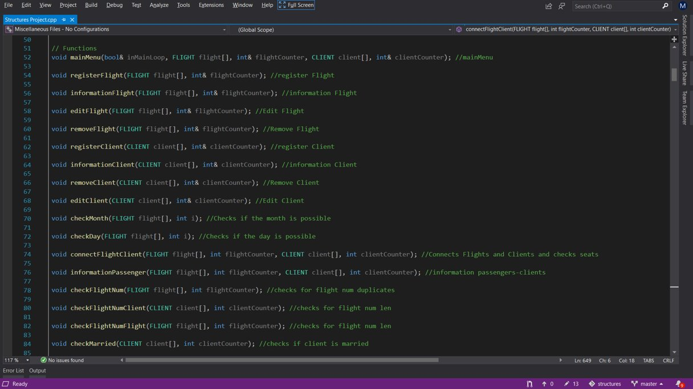

Navigation through the program

Navigating through the program cannot become easier. Using the simple menu that pops up when the program is launched, a person can register a flight or a client, edit, delete information or quit the program.

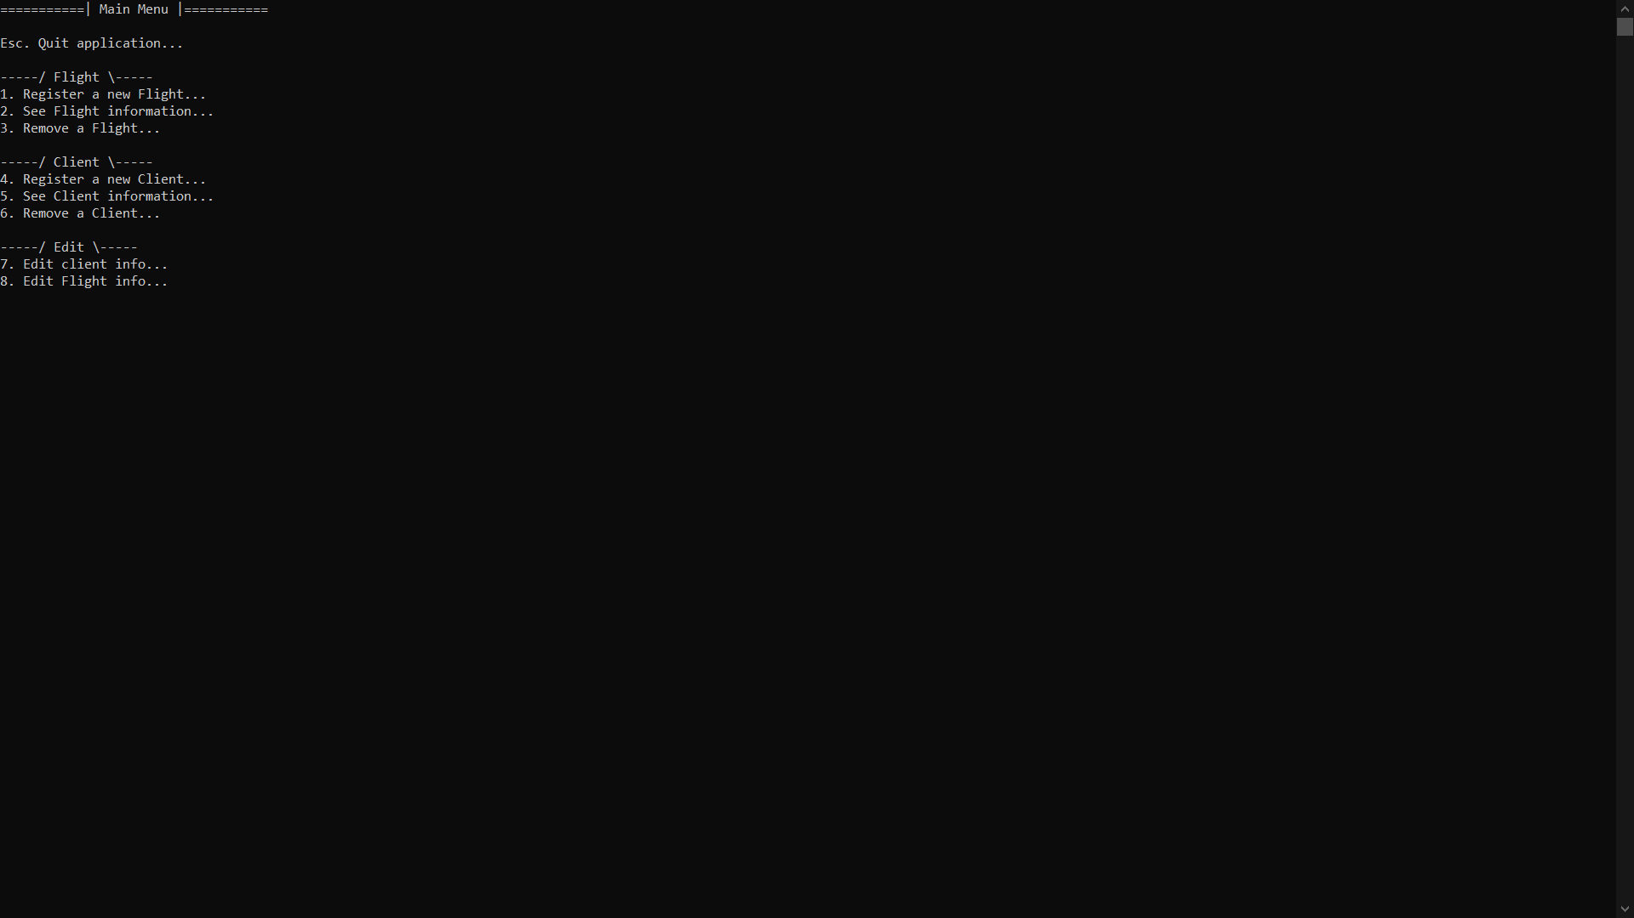

The main menu with clean design provides easy navigation through the program with just one click of a button.

By pressing the number “1" or “4" on the keyboard, the user can register a new flight or a client. He is taken to the register tab where will be asked to provide the necessary information regarding the chosen option.

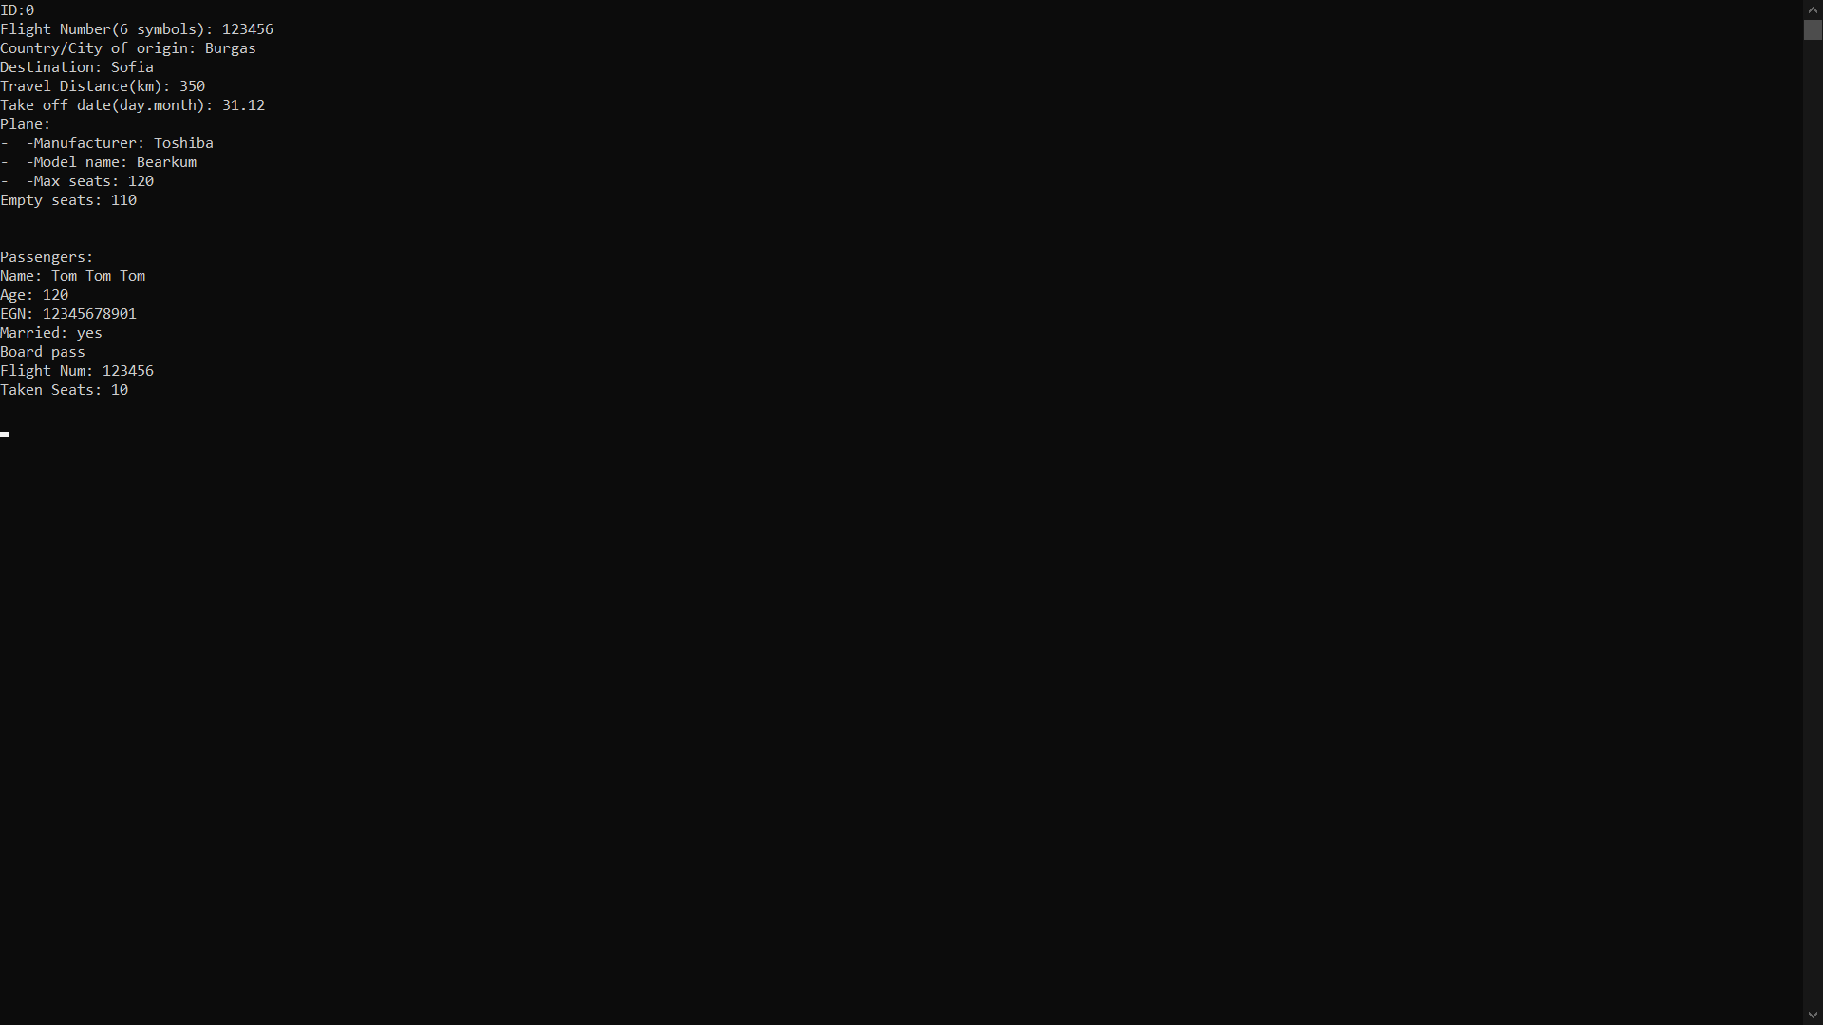

By pressing the number “7" or “8" on the keyboard, the user can register a new flight or a client. He is taken to the register tab where will be asked to edit the information regarding the chosen option.

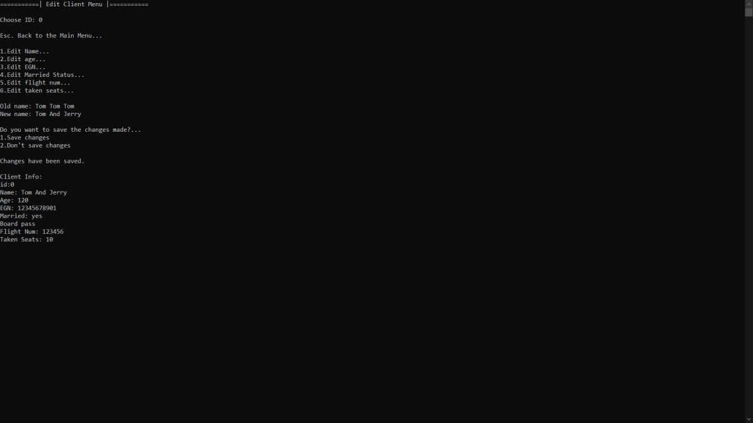

Thank you for the attention